System Scaling & Performance
System scaling refers to increasing a system’s capacity to handle more load while maintaining acceptable performance, reliability, and availability. Scaling can be applied at multiple layers, most commonly at the application and database layers.

- Types of Scaling
1. Vertical Scaling (Scale Up)
Vertical scaling involves adding more resources to a single machine.
Common approaches:
- Increase RAM
- Add more CPU cores
- Upgrade storage (SSD / faster disks)
Example:
Upgrading a server from 8 GB RAM to 32 GB RAM
Characteristics:
- Simple to implement
- Limited by hardware capacity
- Often requires downtime
- Single point of failure remains
Summary:
Same machine, stronger hardware.

2. Horizontal Scaling (Scale Out)
Horizontal scaling involves adding more machines to distribute the load.
Common approaches:
- Add more servers or nodes
- Use a load balancer to distribute traffic
- Scale application instances independently
Example:
Scaling from 1 server to 5 servers
Characteristics:
- Improves fault tolerance and availability
- Supports higher traffic growth
- Adds system and operational complexity
Summary:
Multiple machines working together.

- Scaling the system means we can scale it at different layers, mainly:
Scaling a system can be done at the application level and the database level, using vertical or horizontal scaling techniques.
- Application Scaling
Scaling the application layer to handle more users/requests.
- Vertical scaling: Add more CPU/RAM to the app server
- Horizontal scaling: Add more app instances behind a load balancer
- Examples:
  - Running multiple instances of a web service
  - Auto-scaling app servers in the cloud

- Database Scaling
Scaling the data layer to handle more data and queries.
Database scaling is the process of increasing a database’s ability to handle more data, more users, and more requests without performance issues.
- Vertical scaling: Increase DB server resources (CPU, RAM, storage)
- Horizontal scaling:
  - Read replicas
  - Sharding / partitioning
- Examples:
  - Master–replica databases
  - Distributed databases

- Measuring Latency in Distributed Systems
In distributed systems (especially APIs), latency percentiles are commonly used to understand performance.
Common Latency Metrics
Metric | Meaning | Interpretation
p50 latency | 50th percentile | Median latency. Half of requests are faster, half are slower.
p90 latency | 90th percentile | 90% of requests are faster than this value.
p95 latency | 95th percentile | Shows slower requests affecting a small portion of users.
p99 latency | 99th percentile | Tail latency. Highlights worst-case performance.

Example (1,000 requests)
Interpretation:  - p50 = 95 ms → Typical user experience  - p90 = 180 ms → Most users are fast  - p99 = 900 ms → Tail latency (critical for large-scale systems)  - Max = 2000 ms → Extreme outliers
  Metric | Value
  p50 | 95 ms
  p90 | 180 ms
  p95 | 260 ms
  p99 | 900 ms
  Max | 2000 ms

Why Percentiles Matter
Metric | What it represents
p50 | Typical users
p90 | Majority of users
p99 | Reliability at scale
p99.9+ | Mission-critical systems
Industry examples:
- Streaming & e-commerce (Netflix / Amazon) platforms often track p99 / p99.9
- Banking and trading systems may require p99.99

- How Much Load Can Your Application Handle?
To determine how much traffic your application can handle and how it scales, you combine:
- Load testing
- Monitoring
- Scaling validation

- Types of Performance Tests
Test Type | Purpose
Load test | Validate expected traffic
Stress test | Identify breaking point
Spike test | Handle sudden traffic bursts
Soak test | Long-term stability

Popular Load Testing Tools
- Apache JMeter
- k6
- Locust (Python-based)
- Gatling
- Artillery

- Key Metrics for Application Performance
Before testing, define clear success criteria:
- Requests per second (RPS / TPS)
- Concurrent users
- Response time (e.g., p95 < 500 ms)
- Error rate (e.g., < 1%)
- Resource limits (CPU, memory, DB connections)
Example goal:
“The application should support 5,000 concurrent users with p95 latency under 700 ms.”

- Monitoring System Resources
During load testing, monitor system resources to identify bottlenecks.
What to Monitor
- CPU usage
- Memory usage
- Disk I/O
- Network throughput
- Thread pools
- Database connections
- Cache hit/miss ratio
Monitoring Tools
- Prometheus + Grafana
- Datadog
- New Relic
- CloudWatch / Azure Monitor / GCP Monitoring
Common signals:
- CPU at 90% before errors → CPU bottleneck
- Database connections maxed out → Database bottleneck

- 📊 Performance & Scalability Tools Summary
What to Check | What It Measures | Best Tools | Notes
Requests per Second (RPS / TPS) | Throughput under load (Load/stress testing) | k6, Apache JMeter, Locust, Artillery | k6 is modern & CI-friendly
Concurrent Users | Simultaneous active users (Load/stress testing) | k6, Locust, Apache JMeter, Artillery | Modeled as VUs, threads, or arrival rates
Response Time (p95 / p99) | Latency distribution (Load/ stress testing) | k6, Datadog, Prometheus + Grafana, New Relic | Use prod APM for real users
Error Rate (<1%) | Failed requests (%) (Load /stress/Monitoring) | k6, Locust, Datadog, Prometheus, New Relic | Alert on errors + latency
CPU / Memory | Host & container usage (Load /stress/Monitoring) | Prometheus + Grafana, Datadog, cAdvisor | Essential during load tests
DB Connections | Pool usage & saturation (Load /stress/Monitoring) | Datadog DBM, Prometheus exporters, Native DB metrics | Often the real bottleneck
End-to-End Visibility | Correlate load ↔ infra ↔ app (Load /stress/Monitoring) | k6 + Prometheus + Grafana, Datadog | Gold standard setup

A Very Common “Good” Stack
If you want something battle-tested:
- Load/Stress testing: k6, Apache JMeter (open source)
- Metrics: Prometheus
- Dashboards: Grafana
- Prod monitoring: Datadog or New Relic
This combo covers all 5 metrics you listed cleanly.

What Metrics You Get (Clean Mapping)
Metric | How It’s Collected
RPS / TPS | JMeter → Prometheus
Concurrent Users | JMeter thread metrics
Response Time (p95/p99) | JMeter histograms
Error Rate (%) | JMeter success/failure counters
CPU / Memory | Prometheus exporters (Node / cAdvisor)
DB Connections | DB exporters (Postgres/MySQL/etc.)

How the Integration Works
JMeter → Prometheus → Grafana
- JMeter pushes test metrics
- Prometheus stores time-series data
- Grafana visualizes dashboards
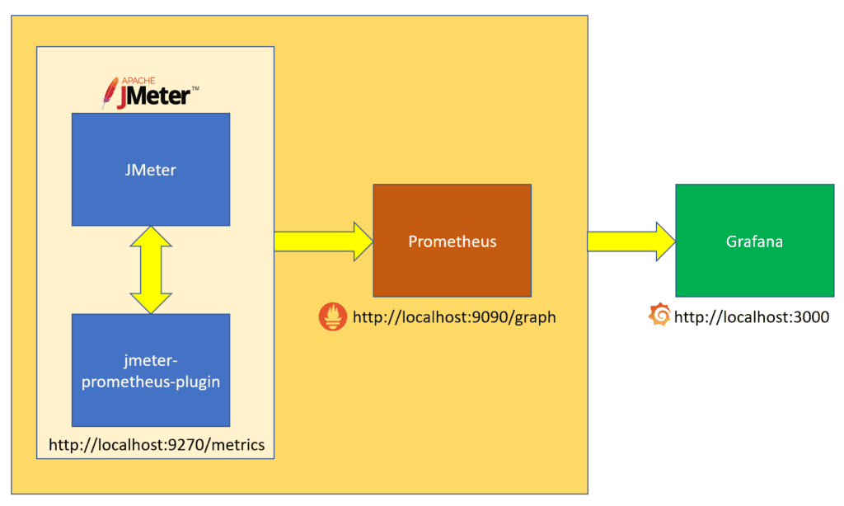
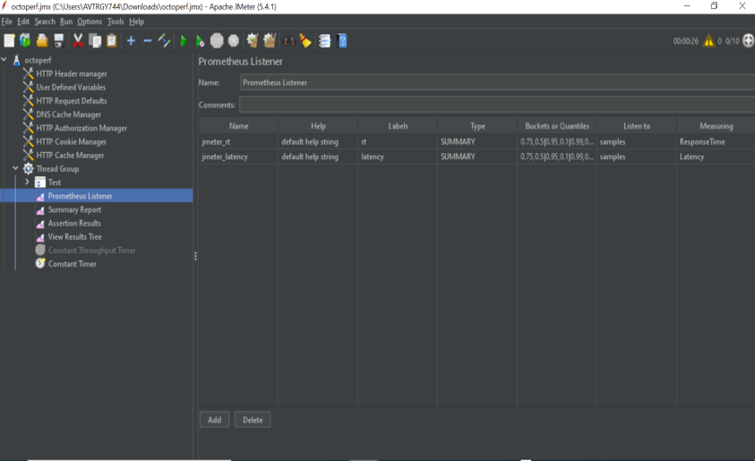

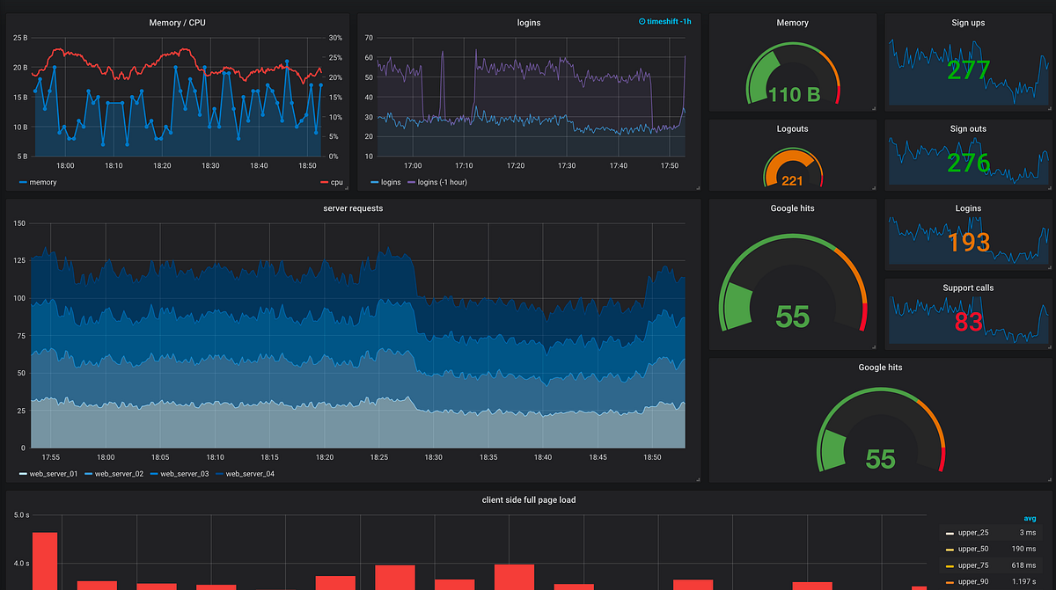
- Summary
Scalable systems require:
- Choosing the right scaling strategy (vertical vs horizontal)
- Measuring performance using percentile-based metrics
- Load testing under realistic conditions
- Continuous monitoring to detect bottlenecks early
A well-designed scalable system balances performance, reliability, and cost as traffic grows.

